**DeadCode Team Project Documentation**

**Project Overview**

**Project Title: Palestine**

**Team Leader: Khalid Ehab Elabd  
Team Members: Ammar Hisham Elsayd ,** **Mohamed atef abo Yousef,** **Abdelrahman Amr** **Sakr**, **Mohamed Yasser Al-Najjar , Omar Maher Sakr**

**Project Description: ShowTruth for Palestine is a web platform dedicated to presenting verified information and truths about the Palestinian cause. The project contains several web pages including the Home page, Sign In & Sign Up pages, ShowTruth page, Donate page, Contact page, and Heroes page. The platform aims to facilitate user engagement, ensure secure authentication, and provide a user-friendly interface for accessing information and contributing to the cause.**

**Table of Contents**

1. [**Project Structure**](https://chatgpt.com/c/d29912b1-41ff-4e27-bfec-a790e48dc3b5#project-structure)
   * [**Front End**](https://chatgpt.com/c/d29912b1-41ff-4e27-bfec-a790e48dc3b5#home-page)
   * [**Back End**](https://chatgpt.com/c/d29912b1-41ff-4e27-bfec-a790e48dc3b5#home-page)

1. **[Language Programming](https://chatgpt.com/c/d29912b1-41ff-4e27-bfec-a790e48dc3b5" \l "technology-stack" \t "_new)**

**Frontend:**

* **HTML5**
* **CSS3**
* **JavaScript**

**Backend:**

* **PHP**
* **MySQL**

**Other Tools:**

**Github Link Code https://github.com/khalidKE/ProjectWeb**

1. **[Pages](https://chatgpt.com/c/d29912b1-41ff-4e27-bfec-a790e48dc3b5" \l "page-descriptions" \t "_new)** 
   * [**Home Page**](https://chatgpt.com/c/d29912b1-41ff-4e27-bfec-a790e48dc3b5#home-page)
   * [**Sign In & Sign Up Page**](https://chatgpt.com/c/d29912b1-41ff-4e27-bfec-a790e48dc3b5#sign-in--sign-up-page)
   * [**ShowTruth Page**](https://chatgpt.com/c/d29912b1-41ff-4e27-bfec-a790e48dc3b5#showtruth-page)
   * [**Donate Page**](https://chatgpt.com/c/d29912b1-41ff-4e27-bfec-a790e48dc3b5#donate-page)
   * [**Contact Page**](https://chatgpt.com/c/d29912b1-41ff-4e27-bfec-a790e48dc3b5#contact-page)
   * [**Heroes Page**](https://chatgpt.com/c/d29912b1-41ff-4e27-bfec-a790e48dc3b5#heroes-page)

**Home Page**

**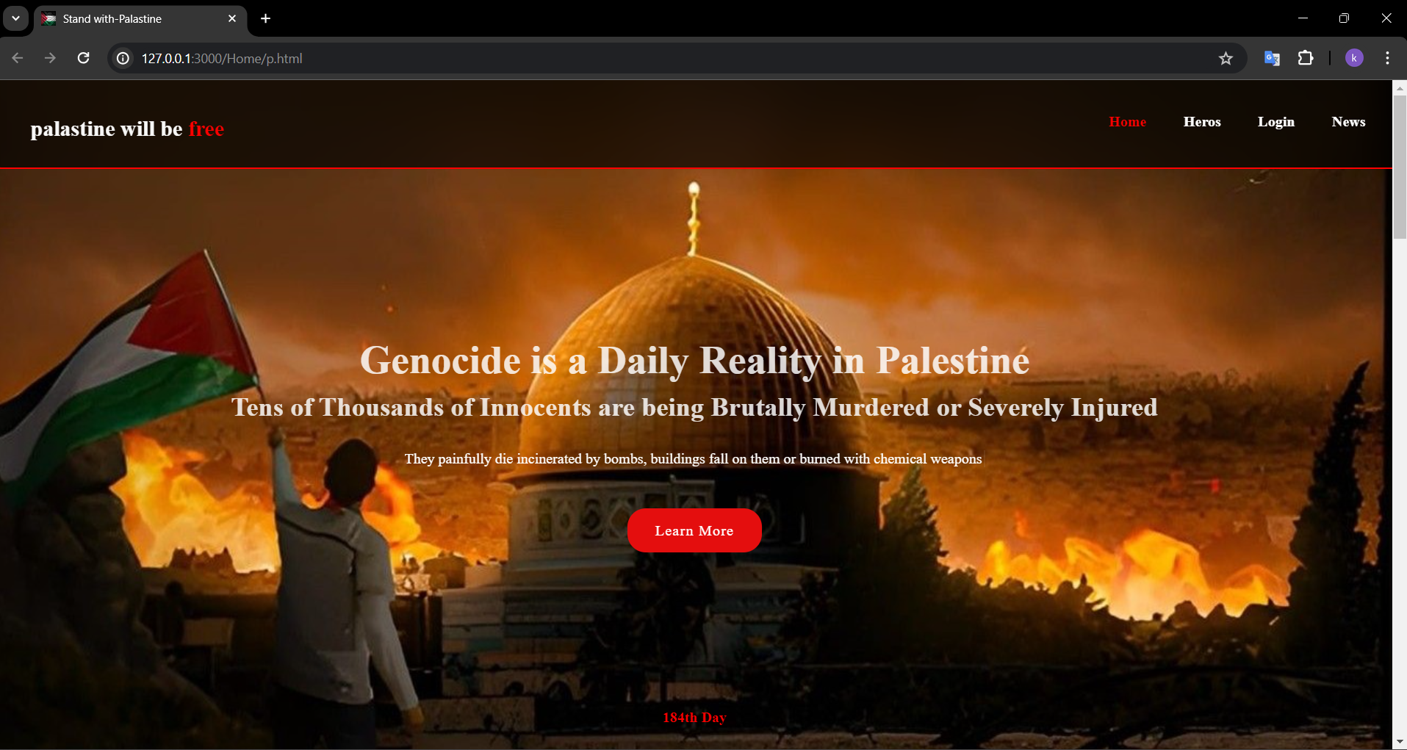**

**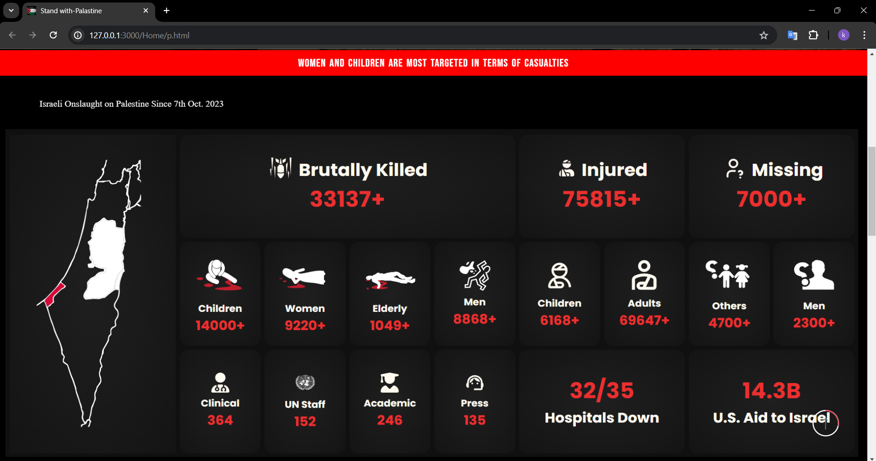**

**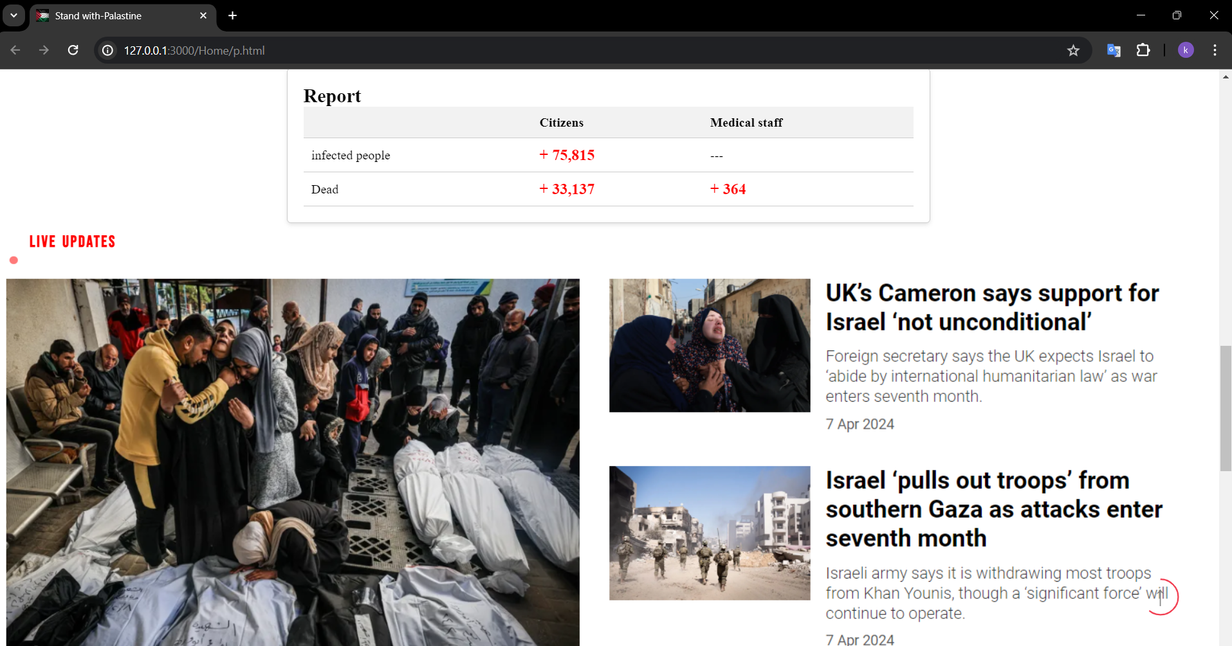**

**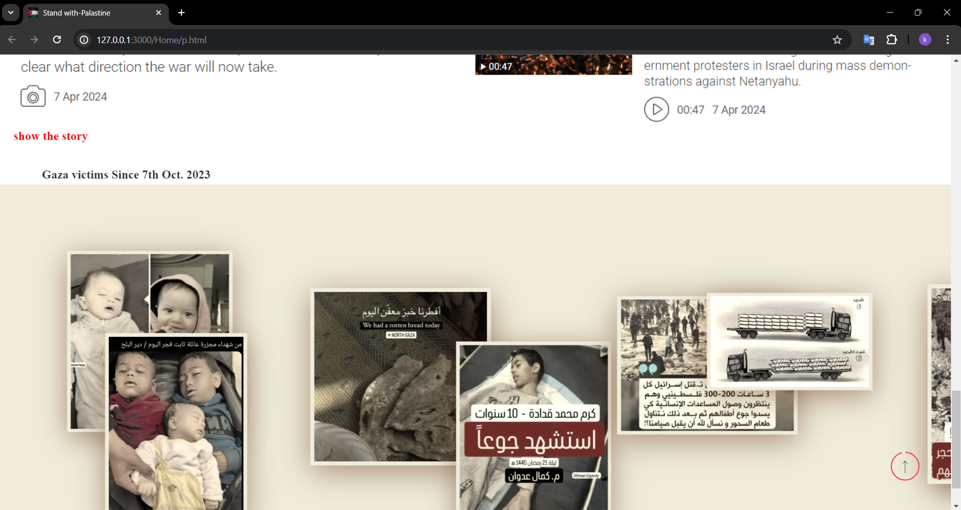**

**Description: The Home page serves as the main landing page for users. It provides an overview of the platform, recent updates, featured truths, and navigation to other parts of the site.**

**Components:**

* **Header**
* **Navigation Bar**
* **Featured Truths Section**
* **Footer**

**Sign In & Sign Up Page**

**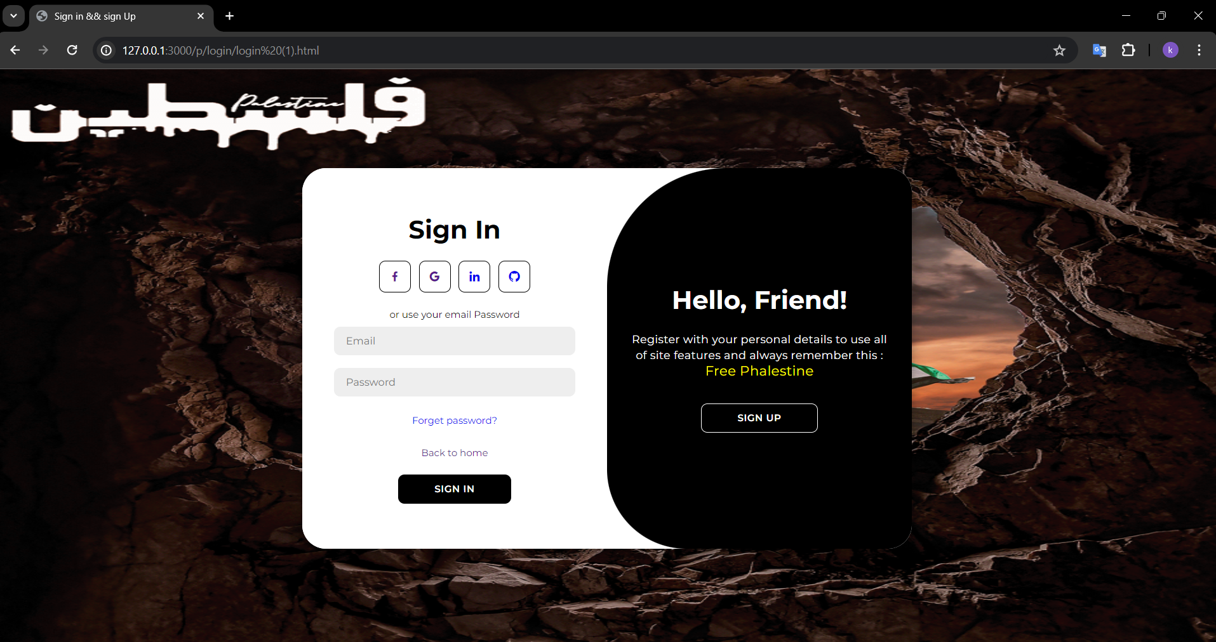**

**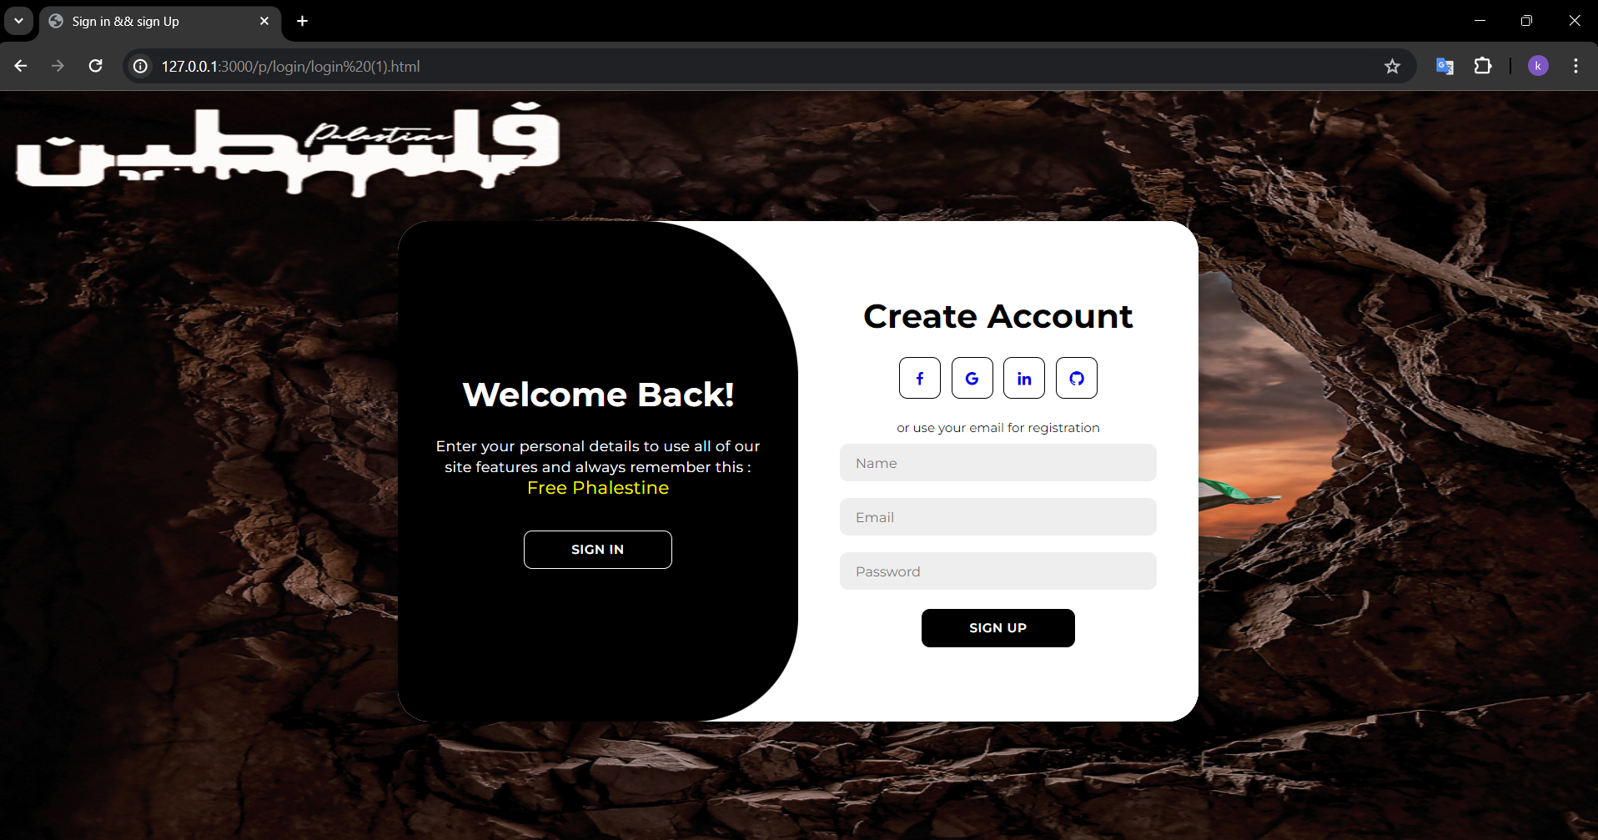**

**Description: These pages enable users to either log in to their existing accounts or register for a new account. They include forms for entering user credentials and validations to ensure data integrity.**

**Components:**

* **Sign In Form**
* **Sign Up Form**
* **Error Messages**

**ShowTruth Page**

**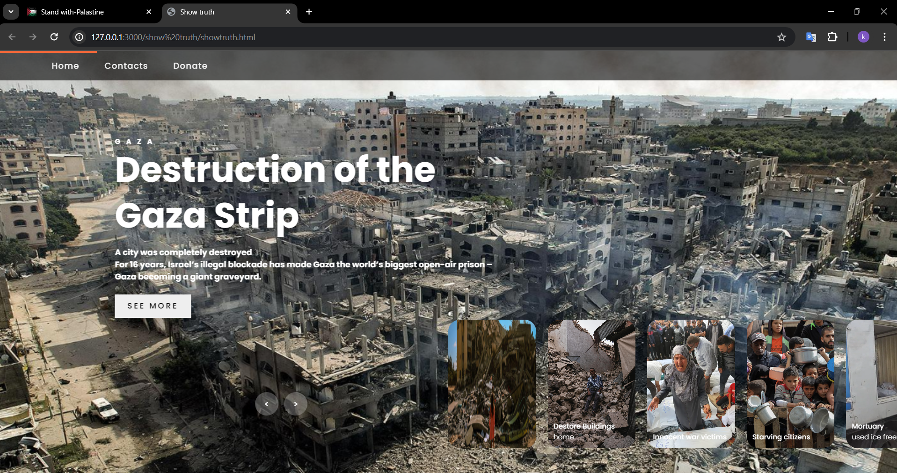**

**Description: The ShowTruth page displays detailed information about verified truths regarding Palestine. It includes filtering options, search functionality, and detailed views of individual truths.**

**Donate Page**

**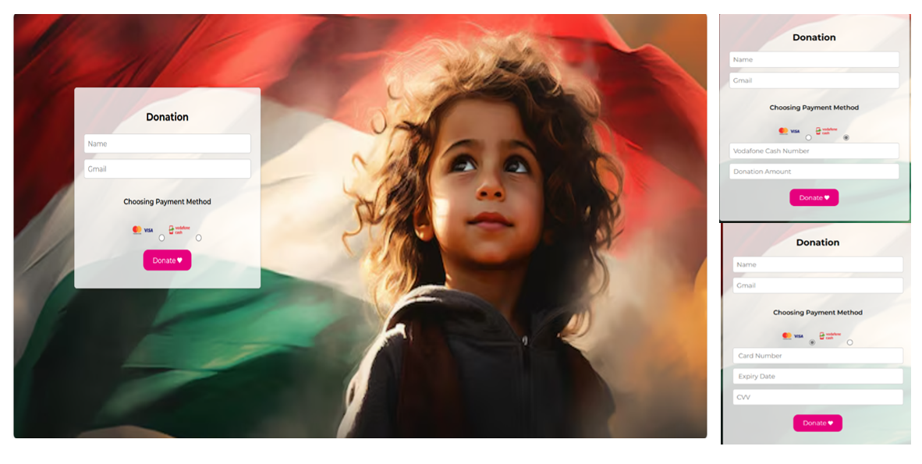**

**Description: The Donate page provides users with options to contribute financially to the platform and support the Palestinian cause. It includes various payment methods and a secure transaction process.**

**Components:**

* **Donation Form**
* **Payment Gateway Integration**
* **Thank You Message**

**Contact Page**

**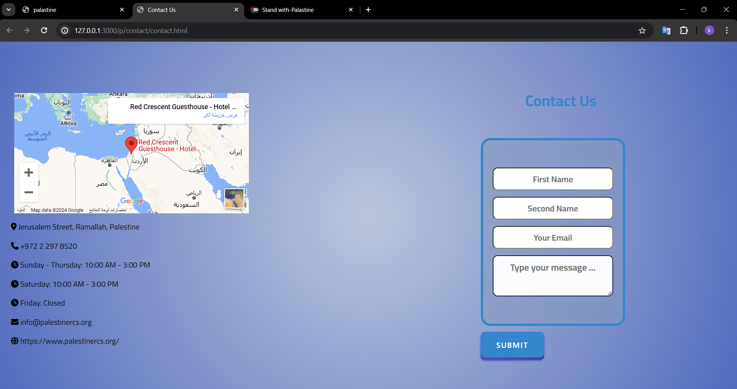**

**Description: The Contact page allows users to get in touch with the DeadCode Team. It includes a contact form for inquiries and a section for team contact details.**

**Components:**

* **Contact Form**
* **Team Contact Information**
* **Google Map Integration**

**Heroes Page**

**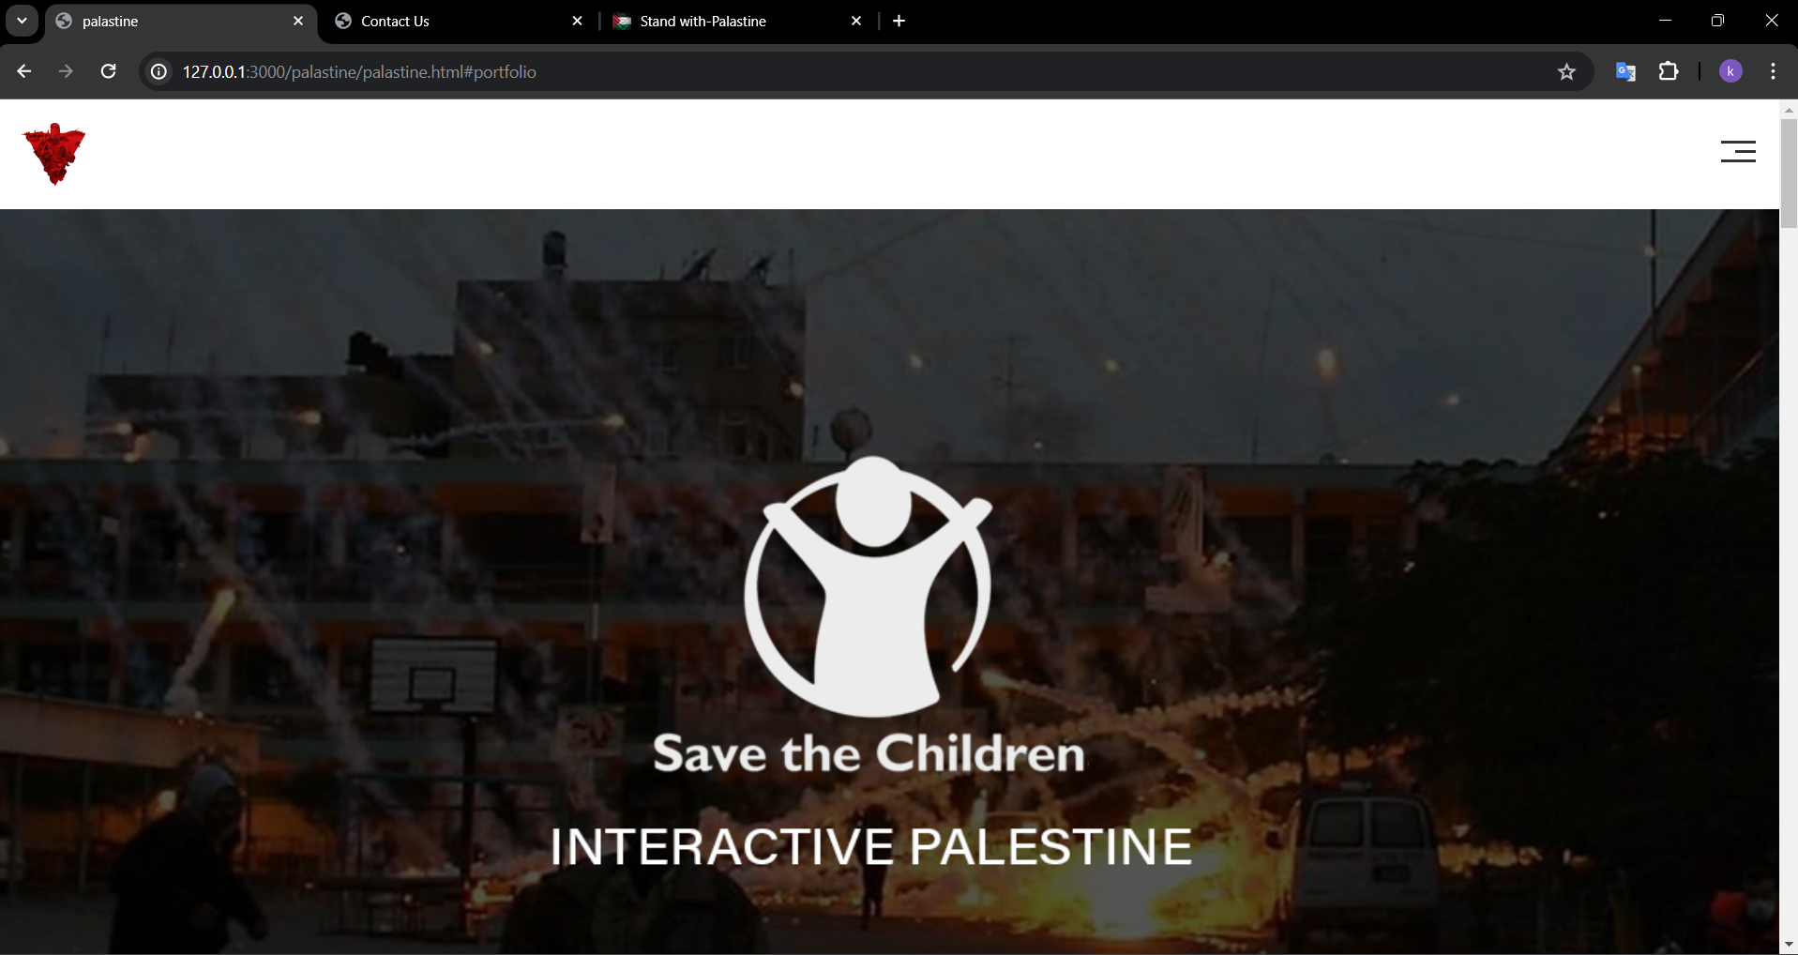**

**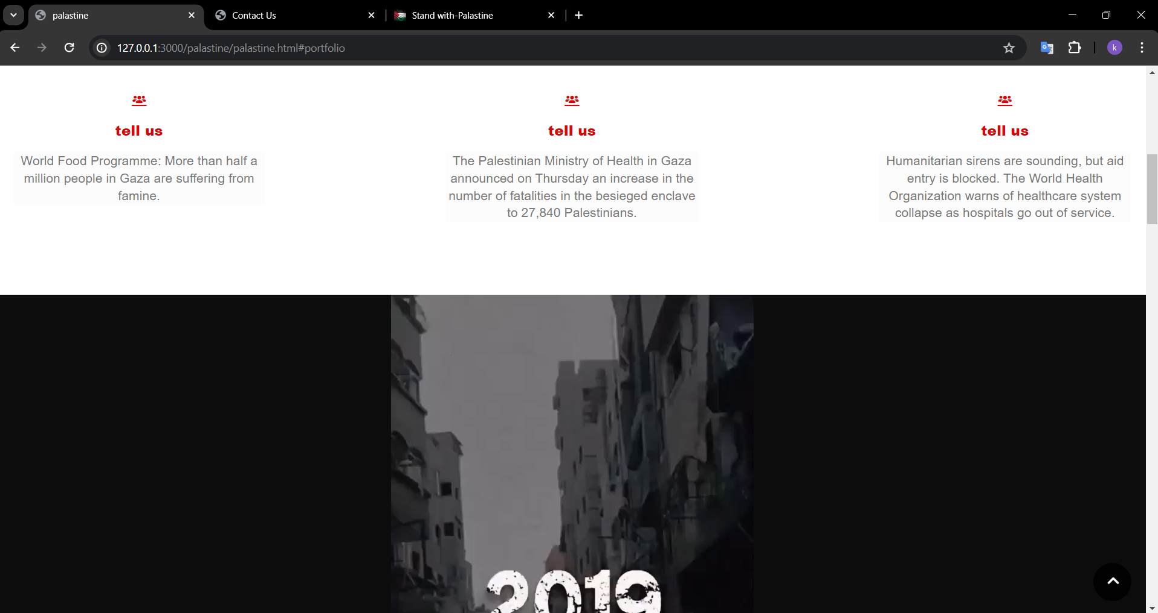**

**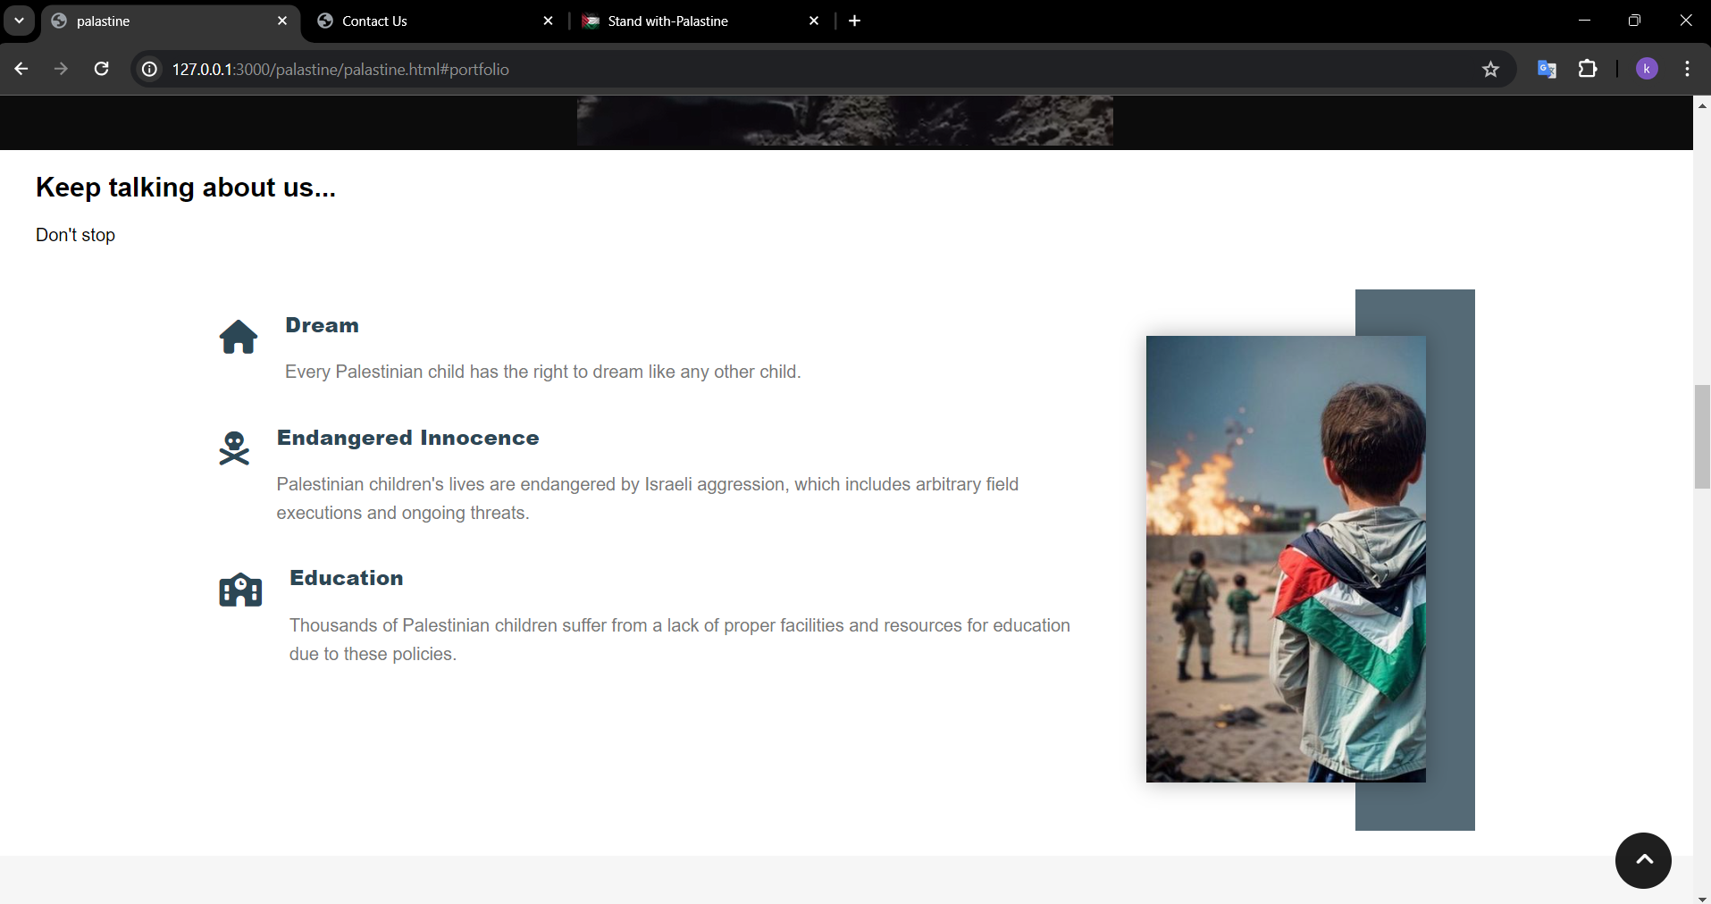**

**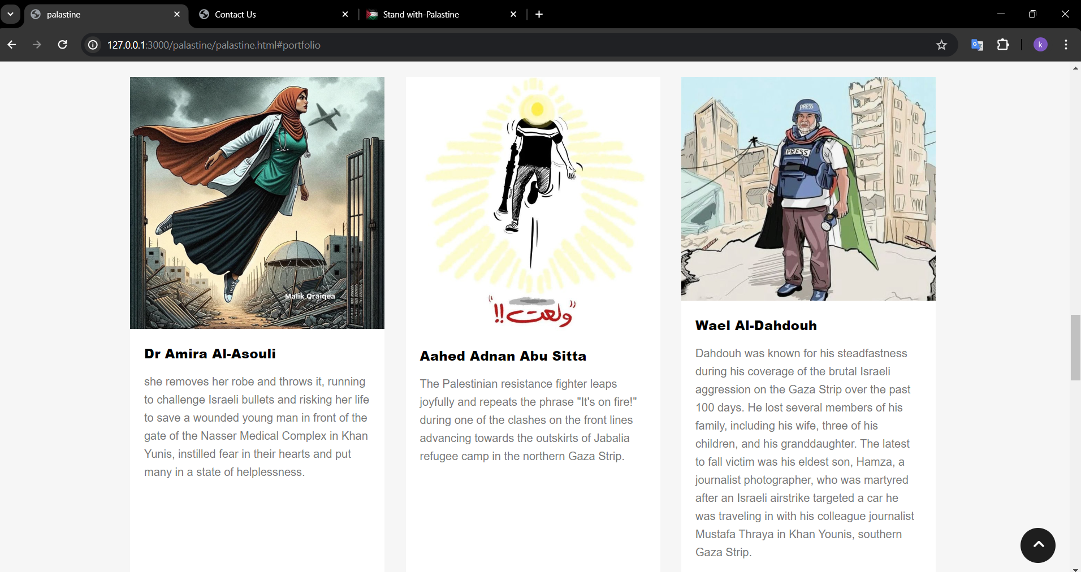**

**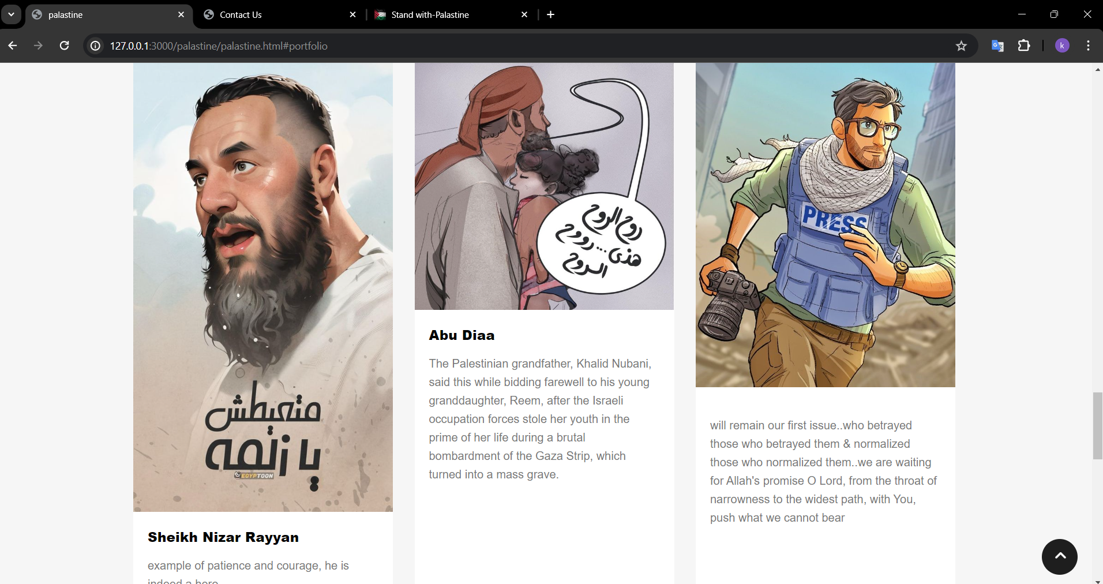**

**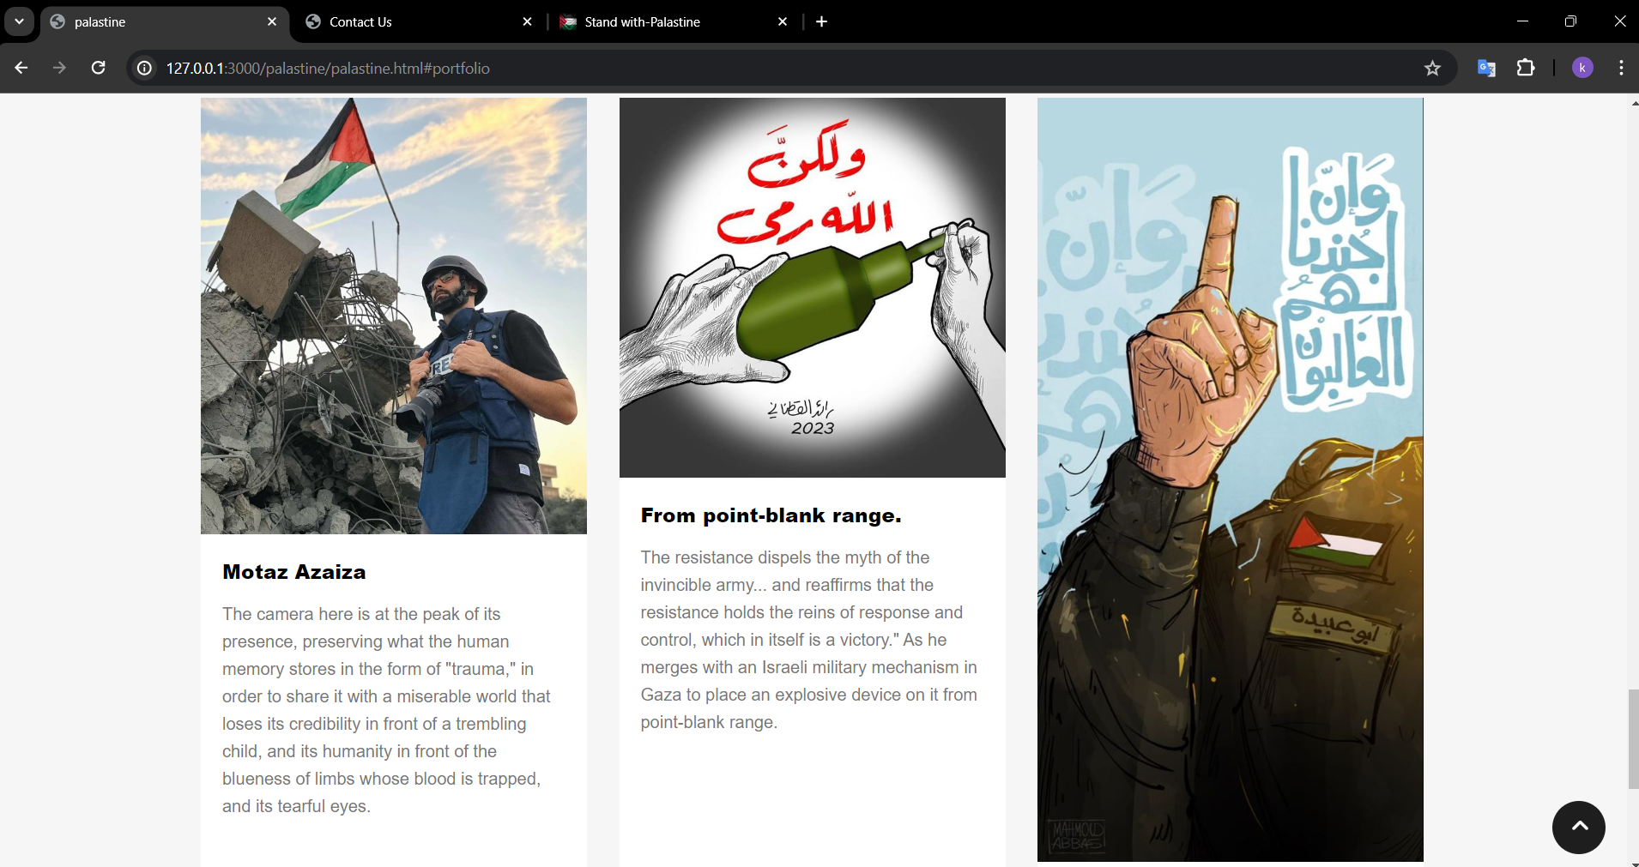**

**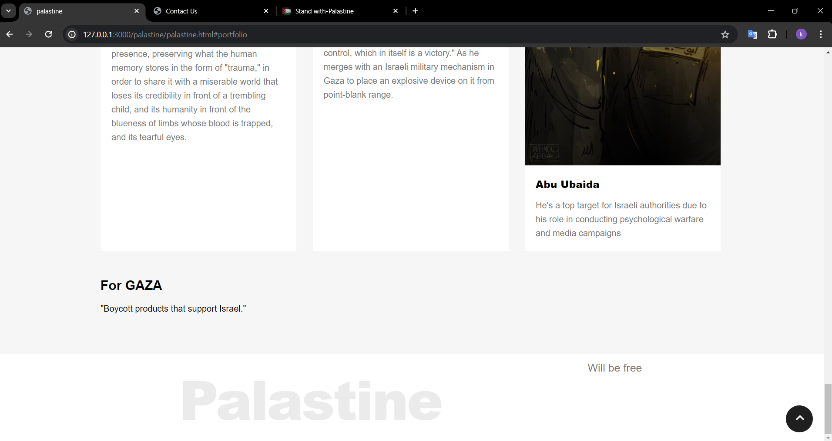**

**Description: The Heroes page honors individuals and organizations that have contributed significantly to the Palestinian cause. It includes profiles and stories of these heroes.**

**About Us Page**

**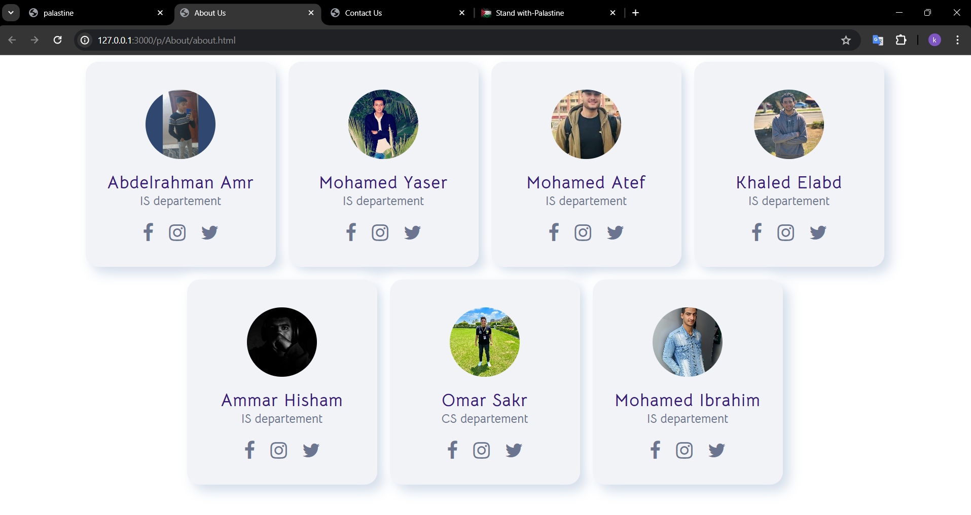**

**Description**

**The "About Us" page provides brief profiles of team members and their respective departments within DeadCode. It offers users insight into the people behind the platform and the organization's structure. The page is designed for clarity and accessibility, with a focus on simplicity and alignment with the platform's overall design theme.**

1. [**Database**](https://chatgpt.com/c/d29912b1-41ff-4e27-bfec-a790e48dc3b5#database-schema)

**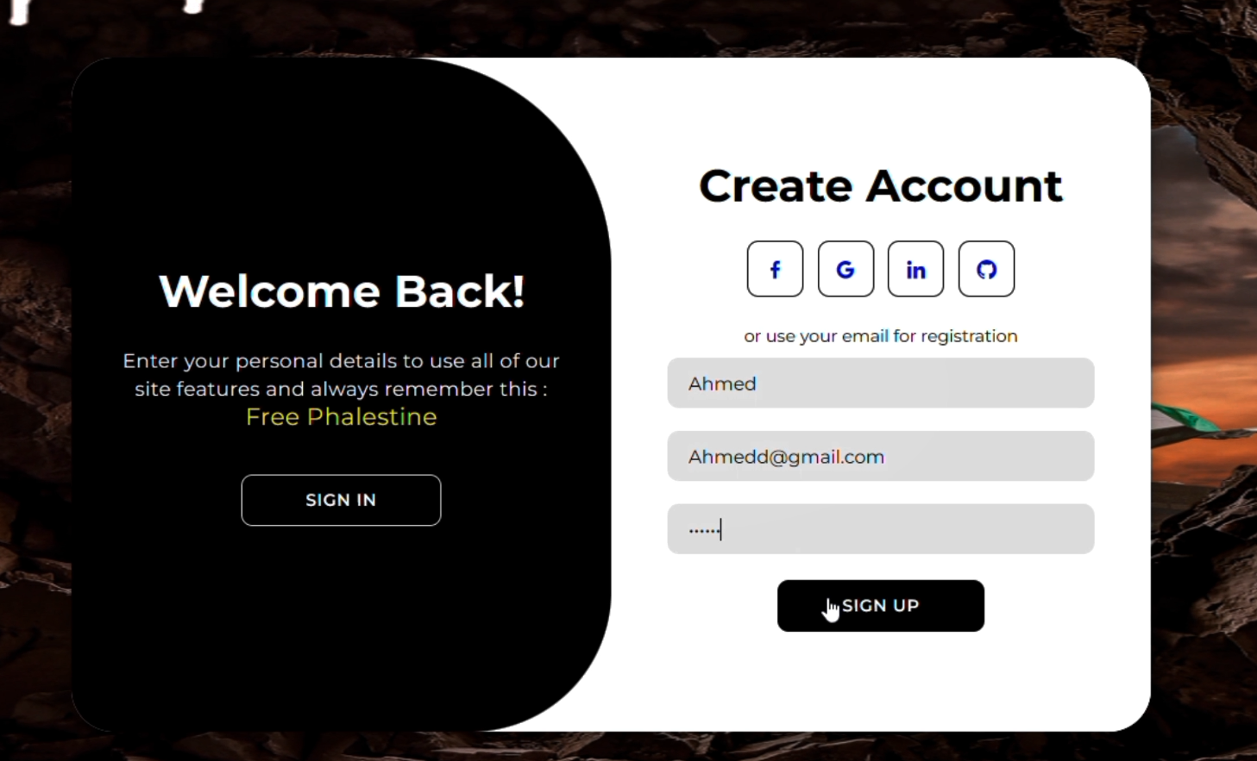**

**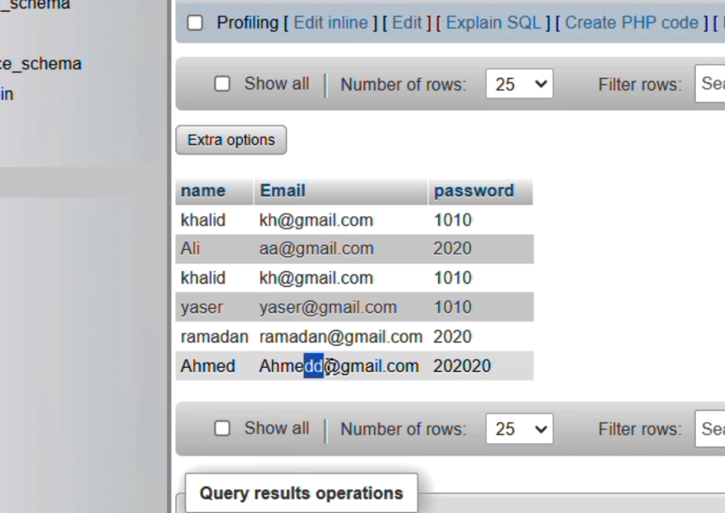**

**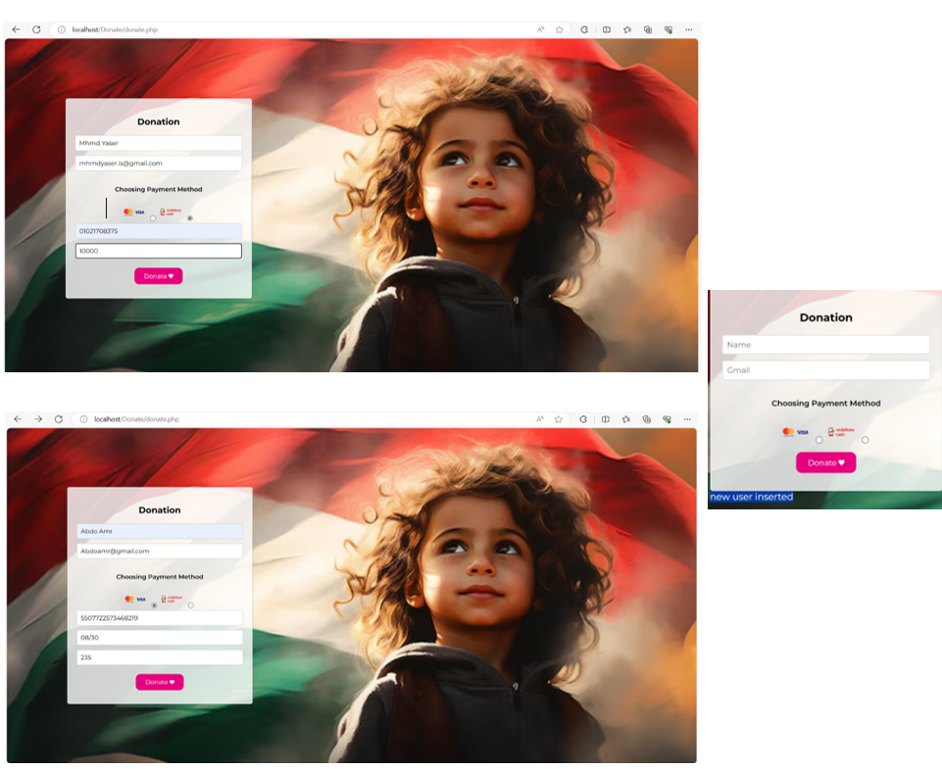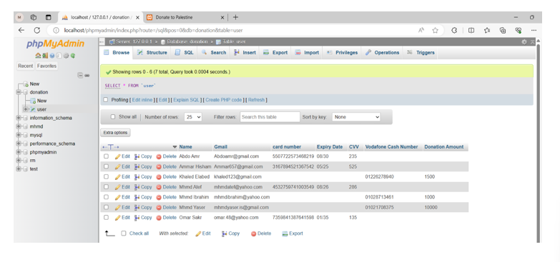**

**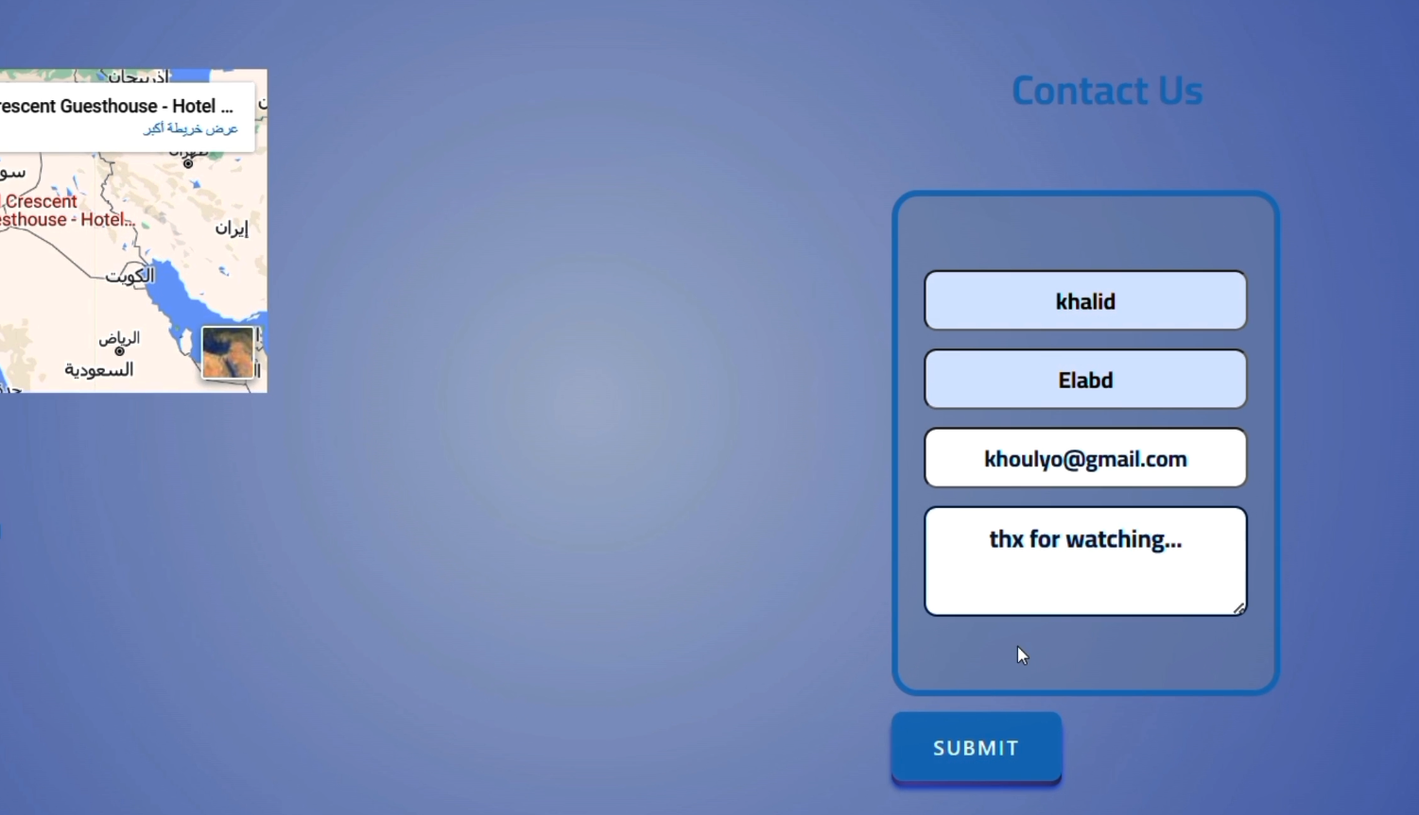**

**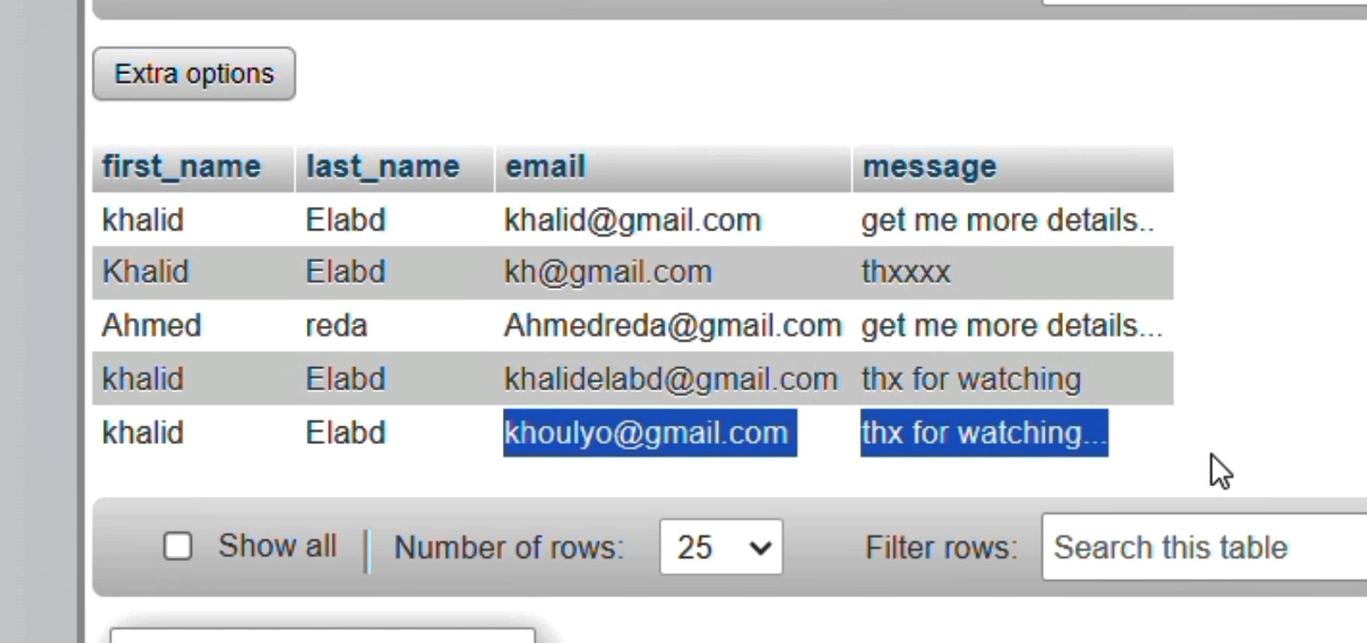**

**Information**

* **Team Leader: Khalid Ehab Elabd - IS**
* **Team Members:**
  + **Ammar Hisham Elsayd-is**
  + **Mohamed atef abo Yousef -is**
  + **Abdelrahman Amr Sakr -is**
  + **Muhammad Yasser Al-Najjar-is**
  + **Mohamed Ibrahim Al-Balaqity -is**
  + **Omar Maher Sakr -cs**

1. [**Acknowledgements**](https://chatgpt.com/c/d29912b1-41ff-4e27-bfec-a790e48dc3b5#acknowledgements)

**We would like to extend our sincere thanks to:**

* **Prof. Sara: For her invaluable guidance, mentorship, and support throughout the project.**
* **Eng. Gomaa: For his technical insights, assistance, and encouragement which greatly contributed to the success of this project.**